spring 2025
Cse-4377 wireless communication systems
the university of texas at arlington


lab 4 report
Submitted toward the partial completion of the requirements for CSE 4377
Under the guidance of
Prof. Jason Losh
By:
Joshua Martinez, 1001374818

Introduction
This lab revolves around signal transmissions from an antenna we created which will radiate into free-space and receive via a PCB antenna. Before starting the lab, an understanding of restricted bands and strength limits are required as to not interfere with important infrastructure around us. Our team decided upon a folded dipole antenna and observed how it radiated a signal through an RF signal generator to power this antenna and a spectrum analyzer on the PCB antenna. With the completion of this lab, we recorded the behavior of this antenna based on distance, direction, and alignment, etc. to better grasp its effect on the signal and understand the limitation and/or benefits of this version. To begin this lab, the decision of the antenna type and its construction are the first steps.

Steps 1-4: Antenna Design w/ Frequency
To start the lab, 2 choices need to be made, which antenna our group will make and the frequency we will operate on. Our choice of a folded dipole will be recorded in the lab as to inform the other teams and reduce overlapping designs. This antenna is made by folding a long copper wire till the two ends nearly meet and folded on two sides to form an elongated oval. The preferred operating frequency for this type of antenna will use the wire length used to build t as half the wavelength and influenced our choice of 725 MHz frequency to use. My partner achieved this number by using an online calculator to roughly estimate this frequency after measuring how the antenna should be formed. Afterwards, the antenna was made to spec from these estimates. As mentioned before, the frequency we decided to use must comply with the OET63 listing restricted bands, low power transmitter frequency table, and such as not to cause interference. To complete this antenna, a cable will need to solder onto it using a small coaxial cable from the lab, removing one end and stripping the wire a bit, and connecting one end of the antenna to power and the other to the ground wire; thus, completing the antenna and these steps.

Steps 5 – 9: Lab setup with antennas
After building the antennas with their chosen frequency, the next steps describe how to set up these antennas alongside the settings for the RF signal generator and spectrum analyzer. Both the PCB antenna and our created one will be attached to one of the mounts in the lab to hold them during testing. Our antenna will be connected to the RF signal generator at our chosen frequency with an acceptable power level. This power level was tuned based on rough estimates on our antenna, such as the 2.1 dBi gain based on the calculator earlier with a set 3m distance between the antennas to start. Afterwards, the power ( -23.35 dBm ) was tweaked until the field stream was at 5000 uV/m. After being checked by the TA with the other antenna connected to the spectrum analyzer with the center set to our frequency with a span of 1 MHz, this concludes the setup for the lab which can be seen from the image below.
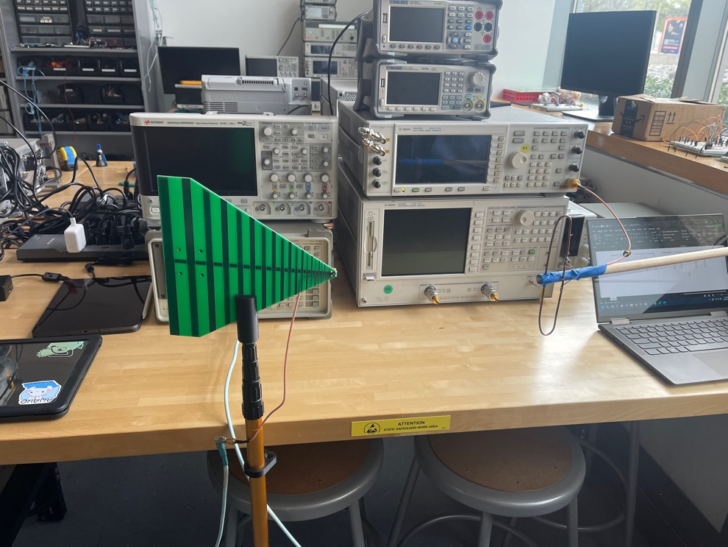

Image 1: Lab setup w/ folded dipole and PCB antenna facing each other near 0.5 m

Step 10: Antenna Testing: Distance
The first part of testing our antenna begins with varying the distance between them to see how this correlates to the transmission and its power. As mentioned, we began with the antennas 3m apart and the image below shows the transmission after getting the OK signal from the TA to start. Another important calculation from the spreadsheet was the wavelength of our antenna which is roughly 0.413m for the 725 MHz frequency. To simply test, we moved the antenna 0.5m closer when recording the table for the table below which demonstrates the power level received at varying distances. As shown in this table, the larger the distance between the transmitter and receiver becomes, the more loss is introduced per step as mentioned during lecture. Once this data has been recorded, this concludes this part of testing.

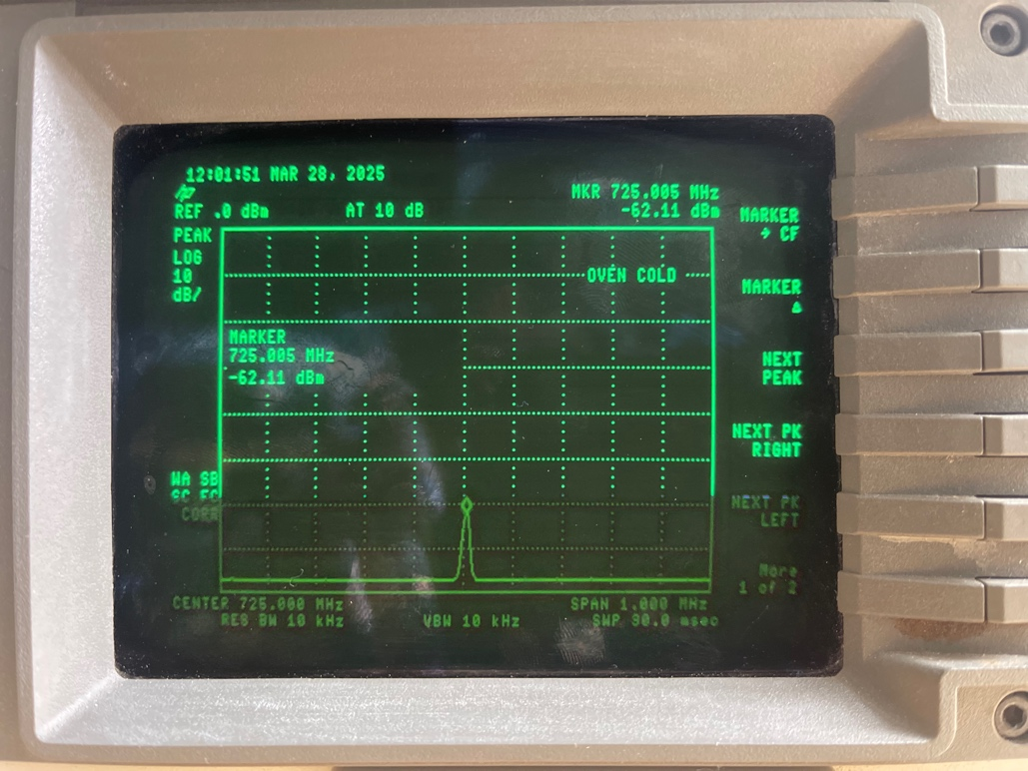
Image 2: Spectrum Analyzer measurement of both antennas 3m apart
Distance(m) | Power(dBm)
3 | -61
2.5 | -57
2 | -55
1.5 | -54
1 | -53
0.5 | -51

Table 1: Antenna power levels over varying distances

Step 11-14: Polarization, Multiple Frequencies, and Off-Bore Orientation
Next in the lab is testing how the transmitted signal is being received by altering either the antennas’ positions facing each other or the operating frequency. Starting with polarization, one of the antennas will be turned in one direction about 15 degrees at a time. Table 2 below shows our recorded data when we rotated our folded dipole antenna which roughly correlates to the expected radiation ‘8’ shape it has. Near a 90-degree offset is when we saw the most loss occur.
Afterwards we realigned the antennas to face each other and will need to vary the frequency generated from the RF signal generator. As the band we choose had around 300 MHz of a safe range to output on, we captured data on every 50 MHz. Table 3 below shows our data and notes that at around 825 MHz was when we experienced the least amount of loss and is probably the best frequency to operate our antenna at.
For the last test, after resetting the frequency output to our original setting, we measured varied angles of off bore alignment of the antennas. Table 4 below reveals the amount of power received by rotating our antenna in the vertical sense and leading to the most loss at around 90-degree offset. To verify the accuracy of the amount of loss we experienced, we require usage of the path loss equation from class to check our numbers, shown in image 3 below. Using 725 MHz as the frequency, 3m as the distance, 2.1 and 6 as the two gains for our antennas, the amount of path loss we experience should be around 29.366 dB. With our power level set to something of -25 dB on the RF signal generator, if we add the expected amount of loss and compared to our recorded data, we experienced roughly 10 dB of loss extra.

Rotation (Degree) | Power (dBm)
0 | -62
15 | -60
30 | -62
45 | -62
60 | -65
75 | -62
90 | -67

Table 2: Antenna rotation with their corresponding power levels

Frequency (MHz) | Power (dBm)
625 | -60
675 | -65
725 | -60
775 | -60
825 | -58
875 | -60
925 | -66

Table 3: Varied antenna frequencies with their corresponding power levels

Off-Bore (Degree) | Power (dBm)
0 | -62
15 | -57
30 | -63
-45 | -64
-60 | -67
-75 | -65
-90 | -70

Table 4: Antenna off-bore rotation with their corresponding power levels

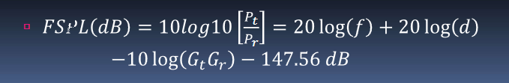
Image 3: Free-Space Path Loss equation used and shown in class

Conclusion
In conclusion, this lab provided experience with antennas and signal transmissions through free space. Despite the multiple types of antennas, each radiates in various ways due to their shapes with our folded dipole having a figure ‘8’ shape. Another key point when choosing an antenna for a specific task, the frequency it needs to operate on will also affect the amount of loss that will occur during transmission. These are important factors that we experienced during lab and verified using tools provided. Overall, this lab helped demonstrate the sort of factors that affect signal transmissions.

